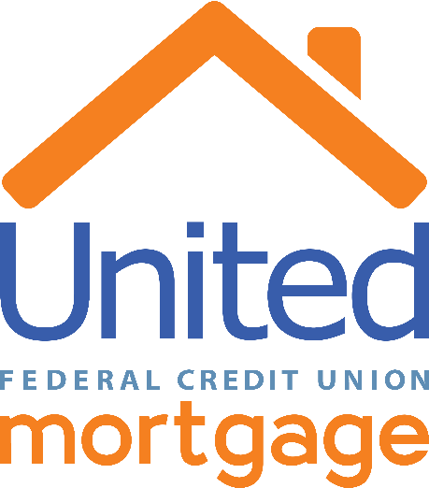

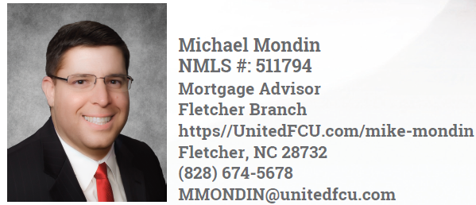

I’m Michael Mondin, a Mortgage Advisor with United Federal Credit Union. Located in Western North Carolina, I’m ready to work with you throughout the home financing process. With more than 20 years’ experience in the industry, I’ll help you find the loan that works for you.

We offer Medical Professional mortgages, Construction lending, Lot lending and 100% first time homebuyer products. We offer both conventional/conforming mortgages and jumbo portfolio mortgages. There are many options for mortgages. The possibilities are endless!

Buying or building a home is a big step, but my reliable team will support you every step of the way. Whether your goal is a new home, vacation home, investment home or refinancing a current residence, I’ll use my experience and market knowledge to help you bring your plans to life.

I graduated from the University of Central Florida with a degree in Finance. In my free time, you’ll find me spending time with my family and 4 dogs.

I worked in Private Banking for large banks for many years before transitioning to United Federal Credit Union where Members enjoy the wide range of personal and business banking products we offer, at the best possible rates. As a credit union, we take pride in the advantages we can offer over traditional banks, like typically fewer fees and greater investments in local communities. United is in the top 100 largest federally insured credit unions in the U.S., with 44 branches covering six states, and $3.8 billion in assets. We’ve maintained a 5-star rating for the past 23 consecutive years from Bauer Financial, one the country’s premier financial ratings services. We take our commitment to both our Members and our communities to heart. That’s what makes a difference in how you experience our people, services, and benefits.

There’s a lot to think about when financing a home, but one thing is clear: in tranquil moments or challenging times, the place you call home always matters.

Let’s get started. Call me today at 828-674-5678 or email me at mmondin@unitedfcu.com.

